The Manual for 05 SR Golden Task

Contents

I. Where can I find SKU that I need to deal with in Riversand? 1

II. How to deal with the task? 8

III. Appendix 9

# Where can I find SKU that I need to deal with in Riversand?

**Step1: Find “05 report(progress>=05)” in the “Shared Search Results”.**

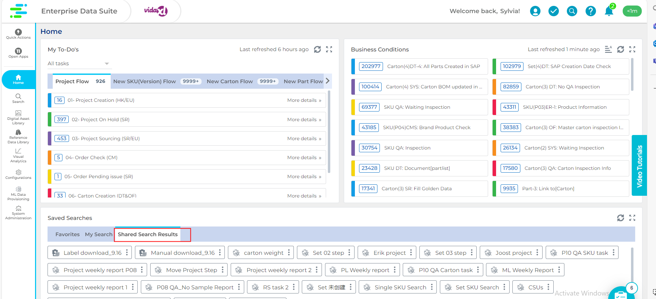

**Step2: Choose the SKUs you are responsible for.**

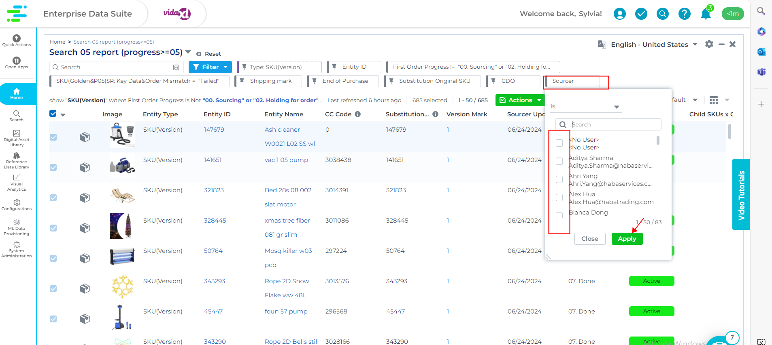

**Step3:**

**Method1: If the QTY of SKUS is too many for you deal with, Download them and choose saved selections in the “Shared Scope Selection” named “05 for report”.**

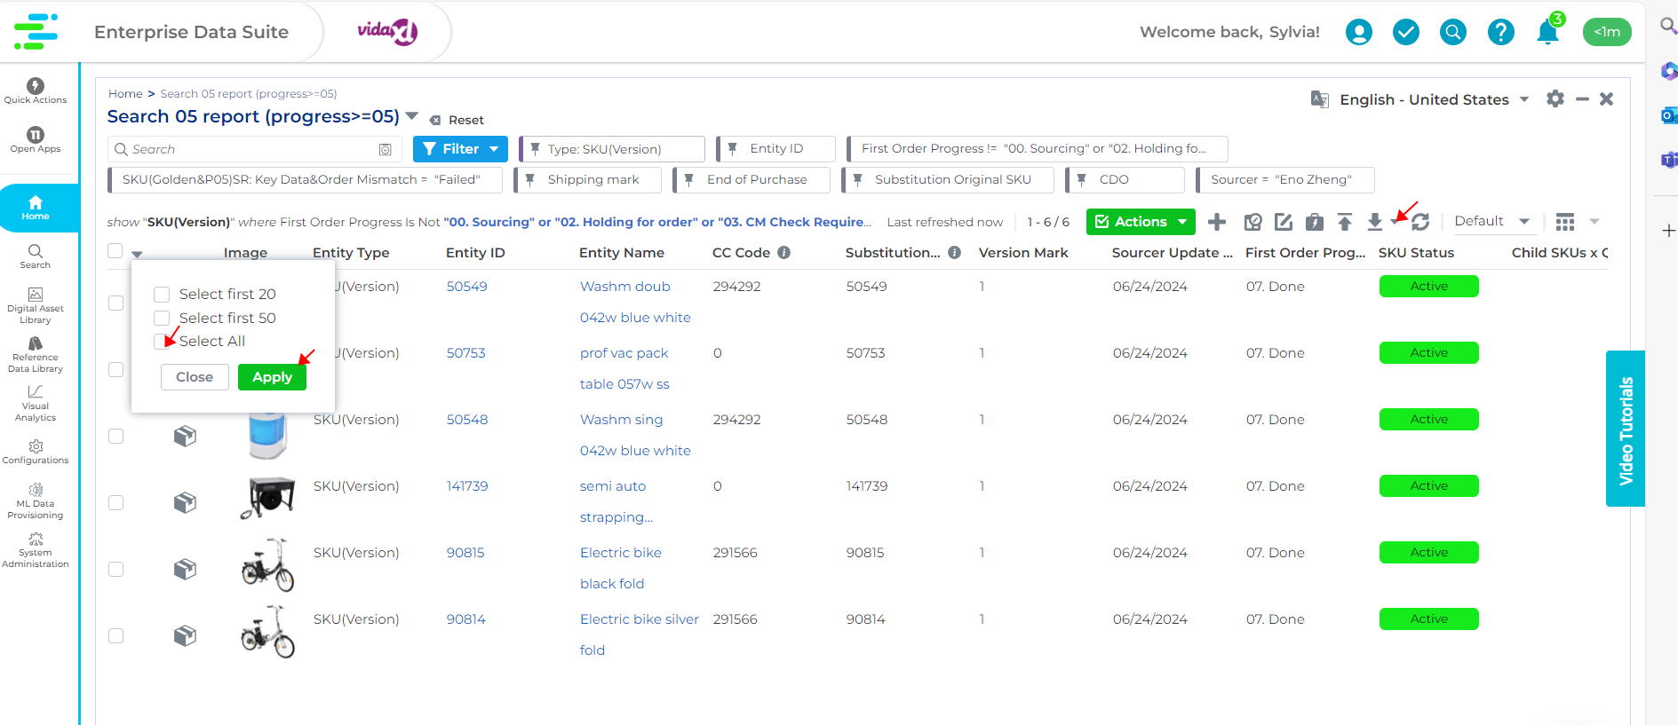

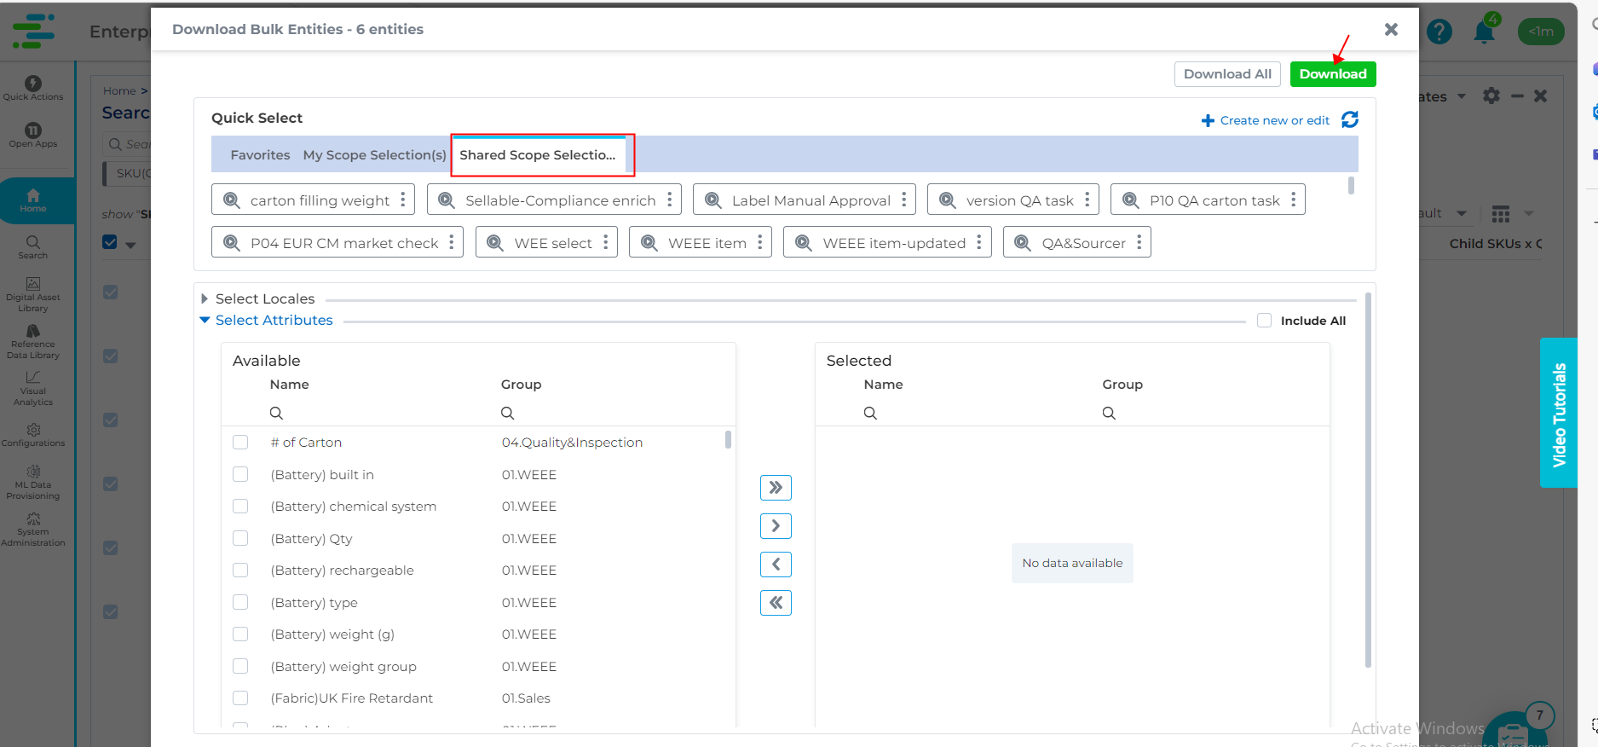

**Method 2: If only a few numbers of SKUs that you need to deal with, you can click the every single SKU to deal with. Then you will see some obvious reminders to guide you how to do with it.(The Screenshot is just one of the situations you might face after you click in the task.)**

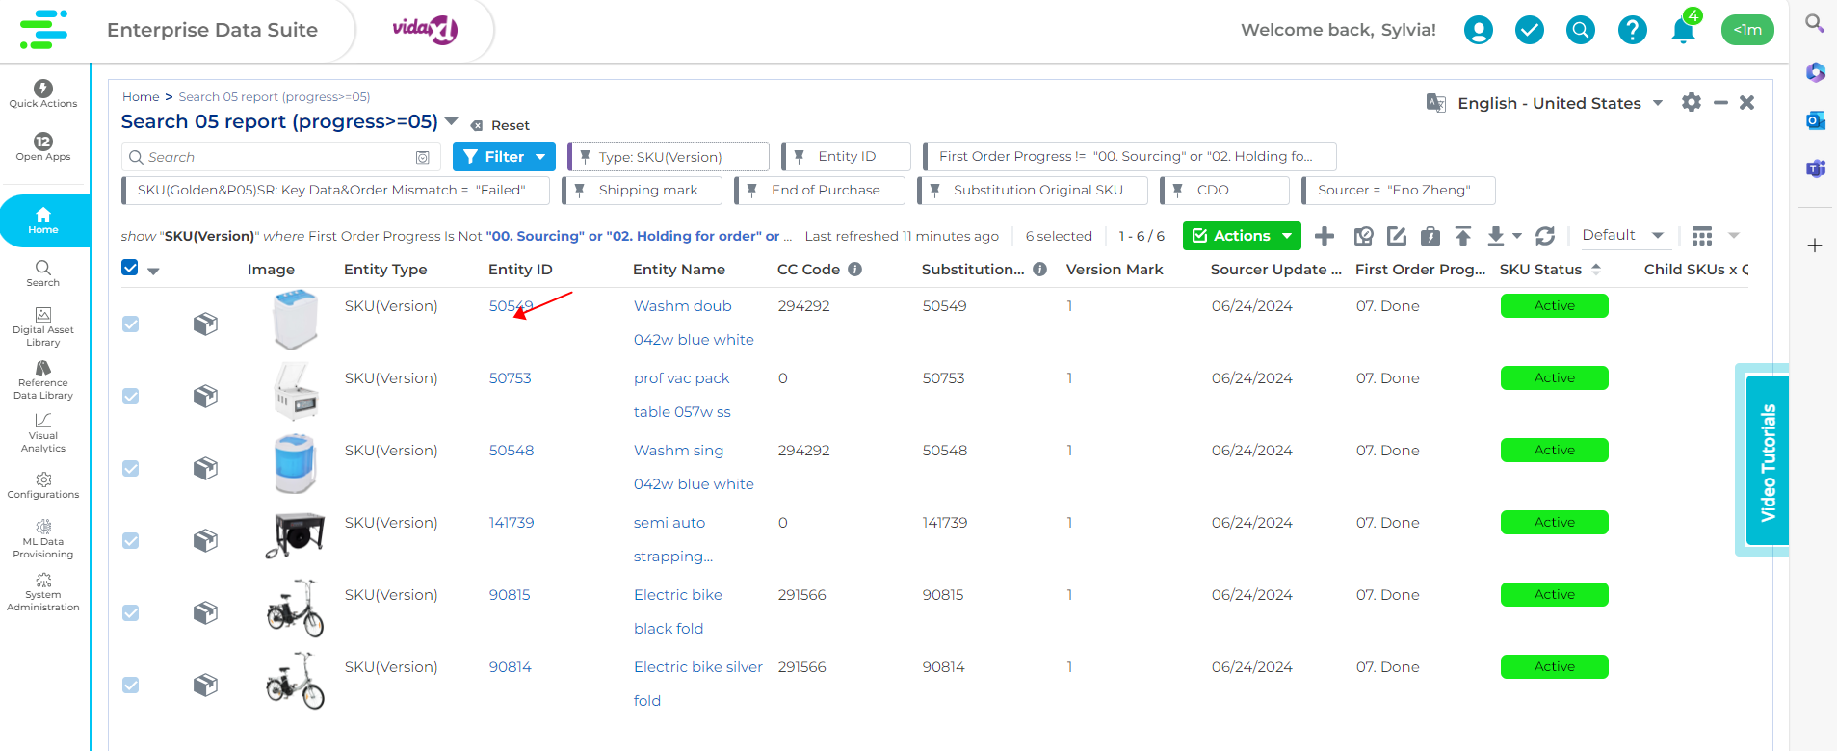

# How to deal with the task?

|  |  |  |  |
| --- | --- | --- | --- |
| **The Reasons why the task opens** | **Relevant Attributes** | **Function Logic** | **How to do?** |
| Version Reason & Previous SKU Mismatch | Version Reason | 1. When "Version Reason" is filled "New Sales Item" and "Previous SKU" has value, the task will fail.  2. When "Version Reason" is filled "Substitution" and "Previous SKU" does not have value, the task will fail. | 1. If the SKU is "New Sales Item", you should clear the value in "Previous SKU".  2. If the SKU is "Substitution", you should fill the value in "Previous SKU". |
| Previous SKU |
| CC code has the same value as the SKU/ SET | CC Code | When the CC code has the same value as the SKU/ SET, the task will fail. | Check whether you upload the wrong CC code unconsciously.  If not, ask Han Luo (Han.Luo@habaservices.com) to apply for the correct CC code. |
| Mismatch with CM Defined Block Rule | CM Defined Block Rule(EUR) | See Appendix! | Check the "Plug Type", "BBQ Gas Connect" and "(Fabric)UK Fire Retardant".   **If some info is correct on your side:** **Method 1:** Ask the CM to check "CM Defined Block Rule" written by them directly. **Method 2:** Wait for their check passively because the CM also have a task to remind them to check "CM Defined Block Rule".  **If some info is wrong on your side:** First, correct them to the right value. Then, if there is no mismatch between info written by SR and CM, this part is finished. If not, refer to the **Method 1** and **Method 2.** |
| Plug Type |
| BBQ Gas Connect |
| (Fabric)UK Fire Retardant |
| Has no project | Sourcing number for mapping | When the SKU does not link one project, the task will fail. | Fill the value in "Sourcing Number for Mapping". (Ways: Bulk Operation, Excel or modify the blank) |
| Sourcing number |
| Lack of Required Info | Power type | 1. When the SKU was placed the repeating order, “Power Type” has electric and the “Plug Type” is empty, the task will fail.  2. When the SKU was placed the repeating order, “Warehouses for first order” has EUR and “UK Fire Retardant” is empty, the task will fail. | Fill the value in “Plug Type” and “UK Fire Retardant”. |
| Plug Type |
| Warehouse for first order |
| UK fire retardant |

# Appendix

|  |  |
| --- | --- |
| **CM defined Block rule** | **Sourcer Info** |
| "Gas Product" | "Gas Connect" not has value |
| Not has "Gas Product' | "Gas Connect" has value |
| "UK upholstered Product" | UK fire Retardant is false or empty |
| Not has "UK upholstered Product" | "UK fire Retardant" is true |
| "EU upholstered Product" | UK fire Retardant is true |
| "EUR Plug Product" | "Plug type" Not has EU or UK Plug |
| Not has "EUR Plug Product" | "Plug type" has EU or UK Plug |
| / | Plug type Both has EU and UK Plug |